**Project Deliverable 2 – Documentation and Coding**

**Faculty Name:** Information Technology

**Module Code:** ITECA3-B12

**Module Name:** Web Development and e-Commerce

**Content Writer:** Kariboba Mpwampu

**Copy Editor:** Mr Kyle Keens

**Submission Date:** Block 2 Week 4

|  |  |
| --- | --- |
| **Student Name** |  |
| **Student Number** |  |
| **Project Title** |  |
| **Submission Date** |  |

**Table of Contents**

2.1 Introduction 3

2.2 Prototyping 3

2.3 Designing 3

2.4 Coding 3

2.5 Conclusion 4

2.6 Sign-off 4

# Introduction

With the problem of obesity and unhealthy living rising around the world as every day people around the world are consigned to less physically active jobs as well as the ever increasing portion sizes and fatty foods in this day and age.

This is a increasing problem that needs a modern solution, a tool to not only help people live healthier more enriching lives. But also educate them so better avoid common pitfalls and have a lifestyle change and not some crash diet. In response to this we have devised a project to meet all of these demands.

In this project we are designing two website applications for Fitmen inc. these websites will have tools to help consumers become more knowledgeable in the fitness and health while also providing tools to help them with their health journey, these tools will include a BMI calculator, various low calorie high filling meals and recipes and daily calorie counter. One website will be based on a more simpler design with hard facts and daily tips, while the other be more detailed recipe’s and information.

The sponsor will then pick which website more appeals to them and implementation will then go forward

# Prototyping

Provide the screen shots of the two responsive prototypes asked in the project specification document. Each prototype must illustrate how all the pages of the website will be displayed on smart phones, tablets, and desktops.

**Prototype 1**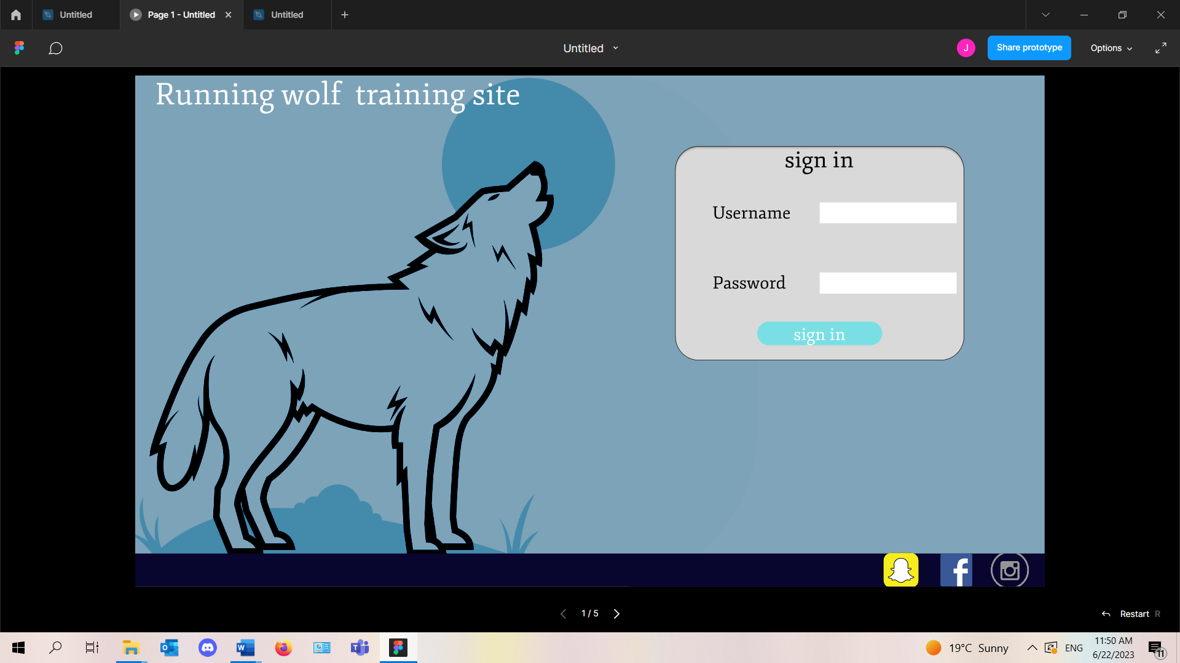

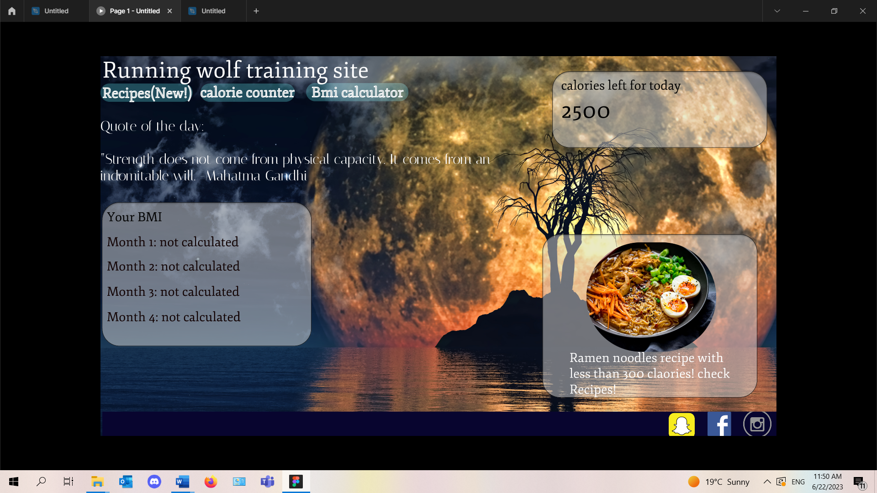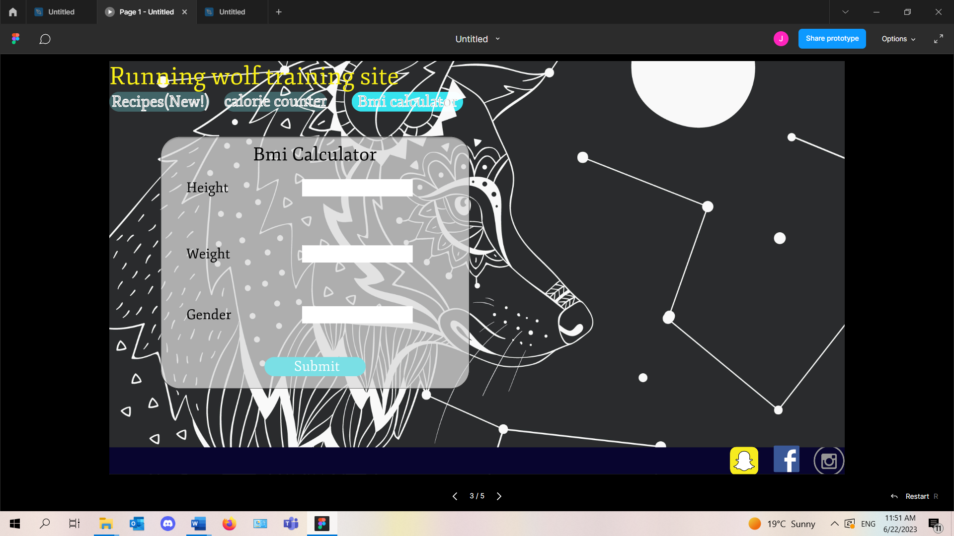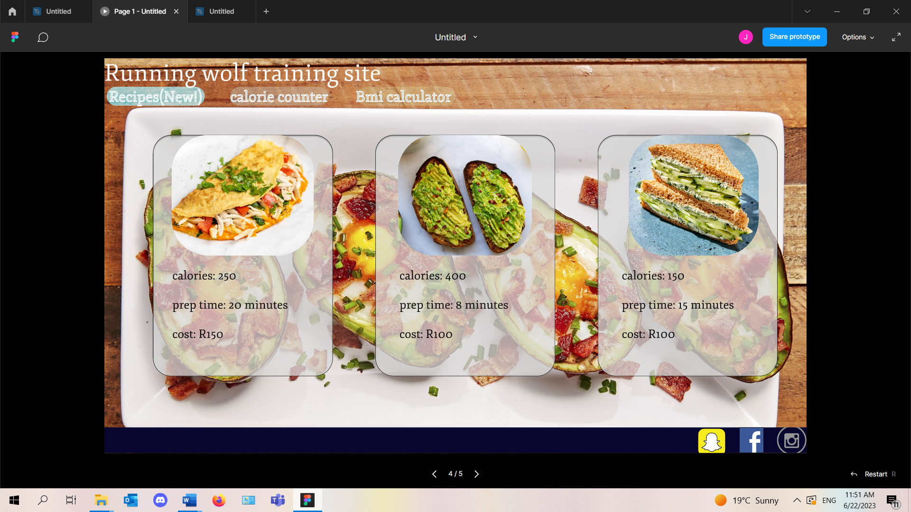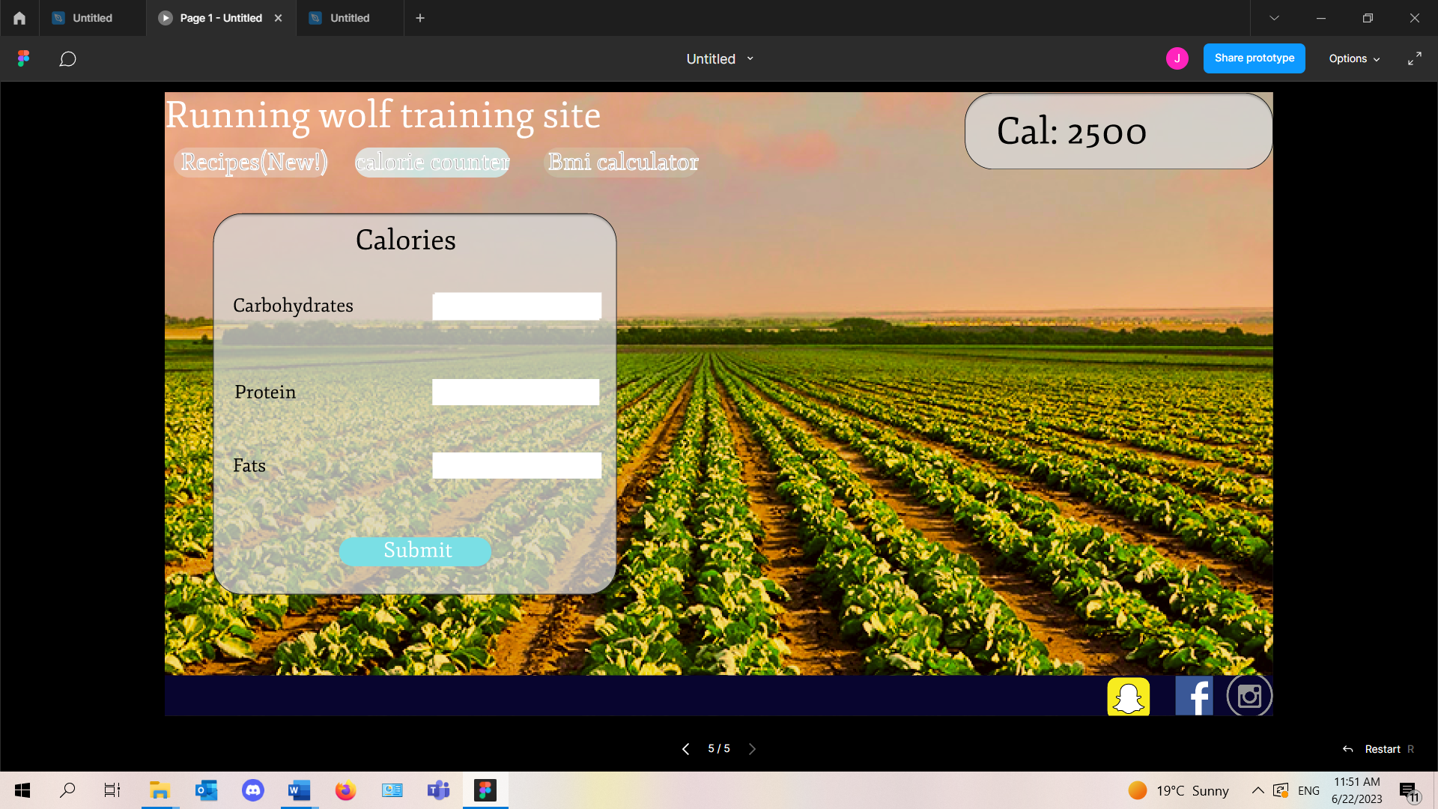

**Prototype 2.**

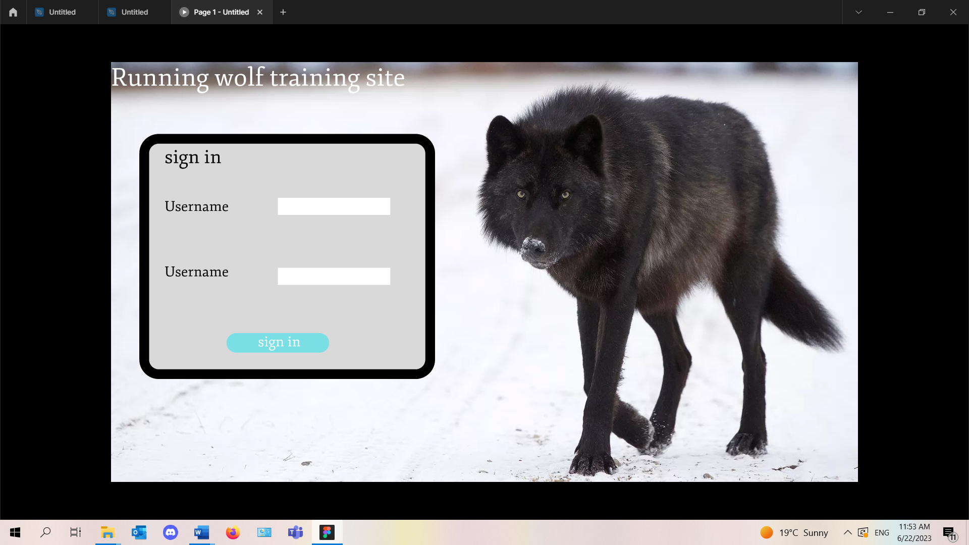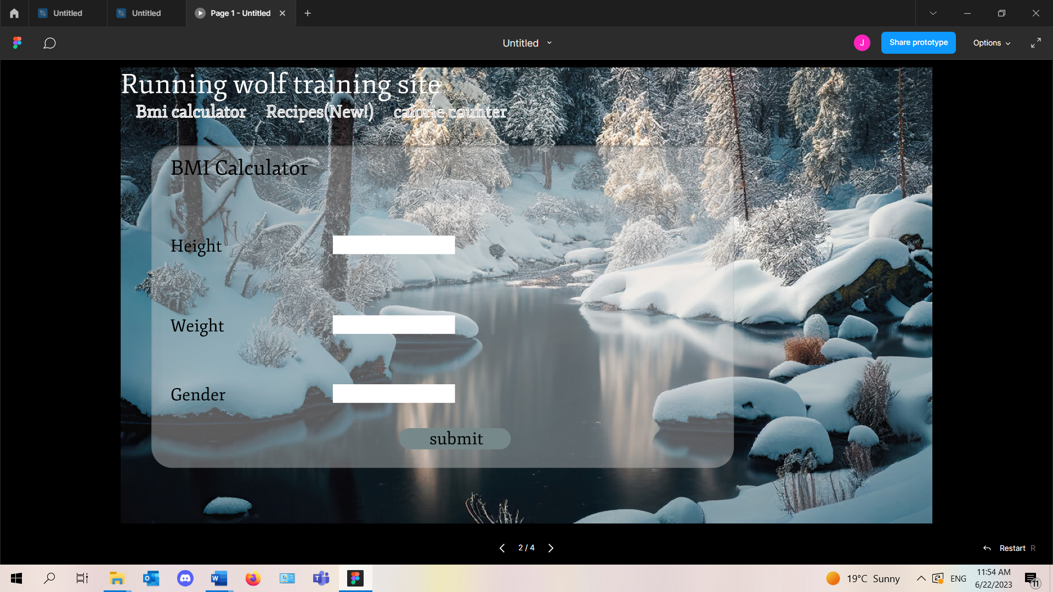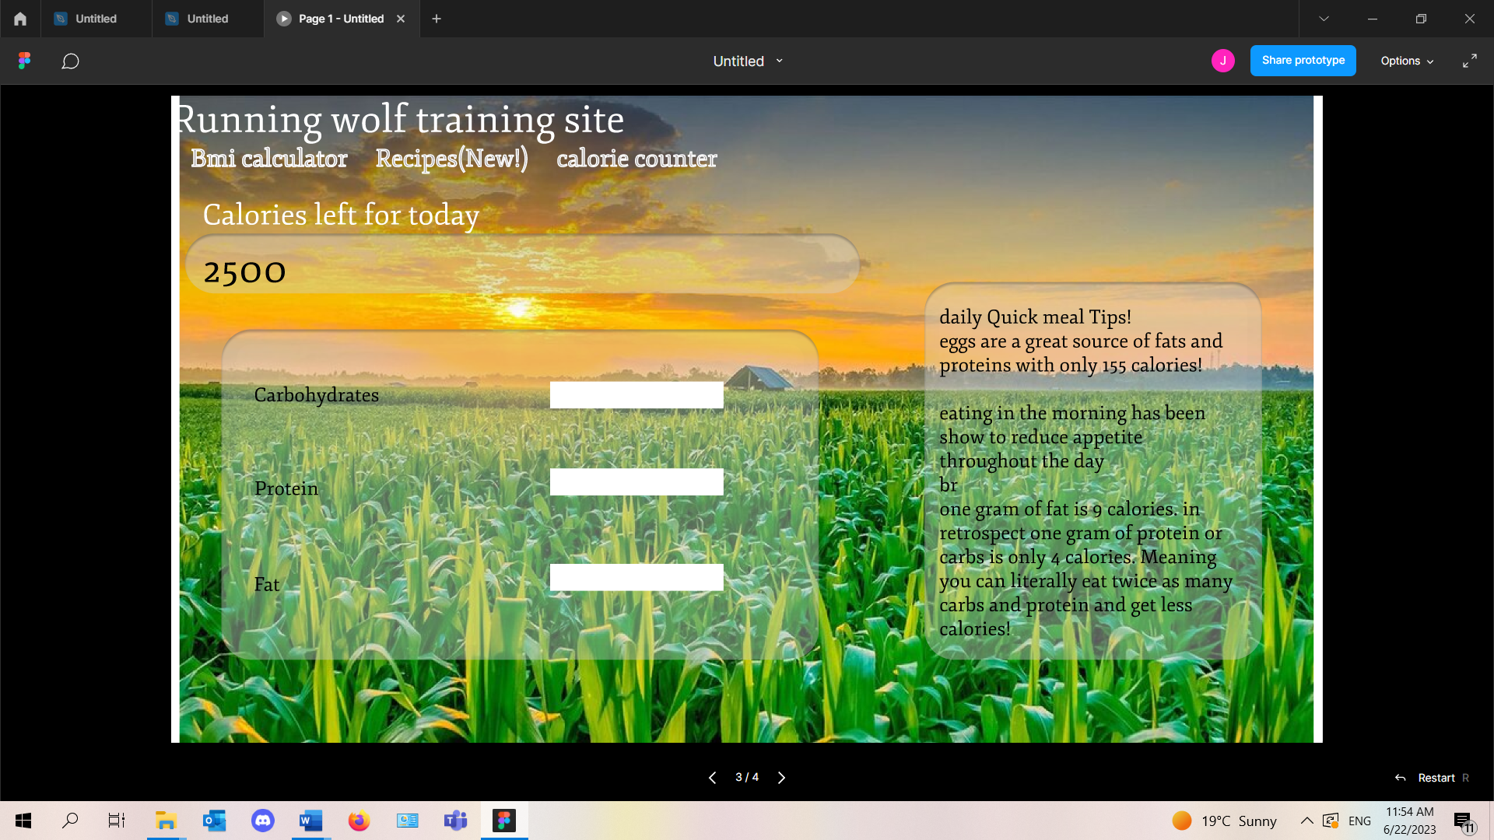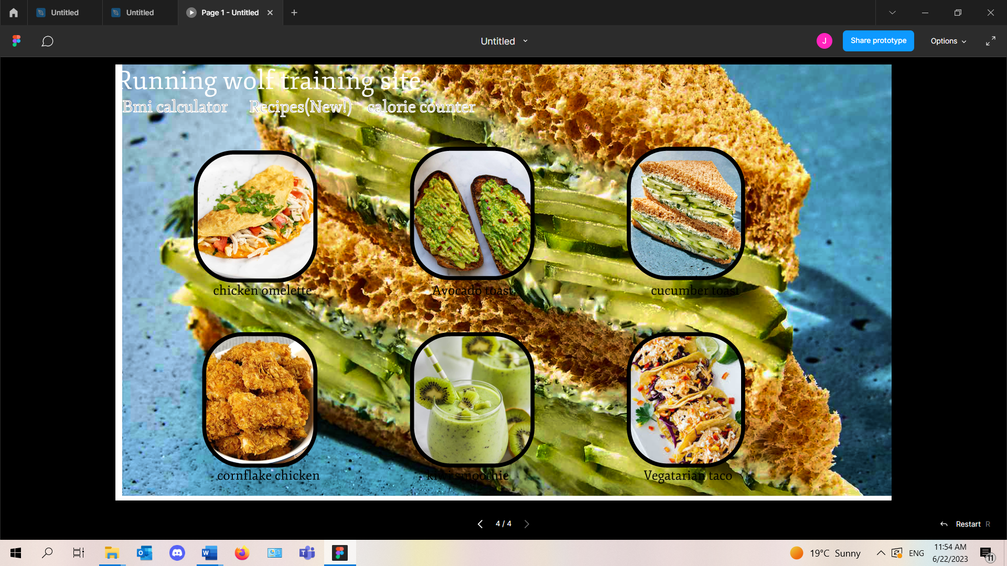

**The client has decided to go with prototype 2**

# Designing

1. 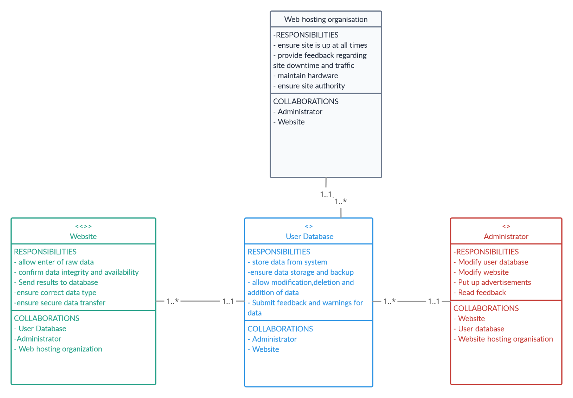
2. 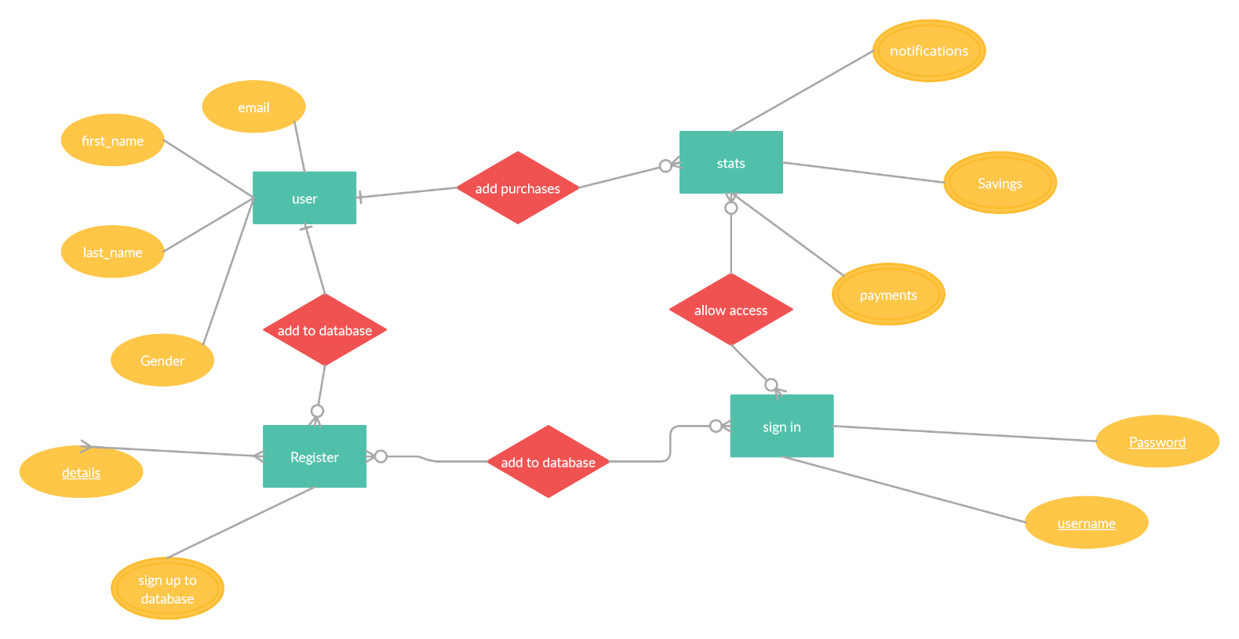
3. 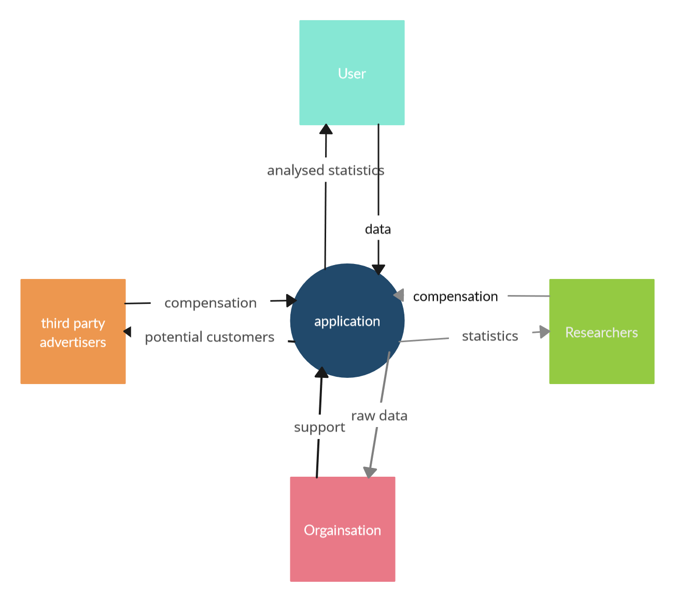
4. 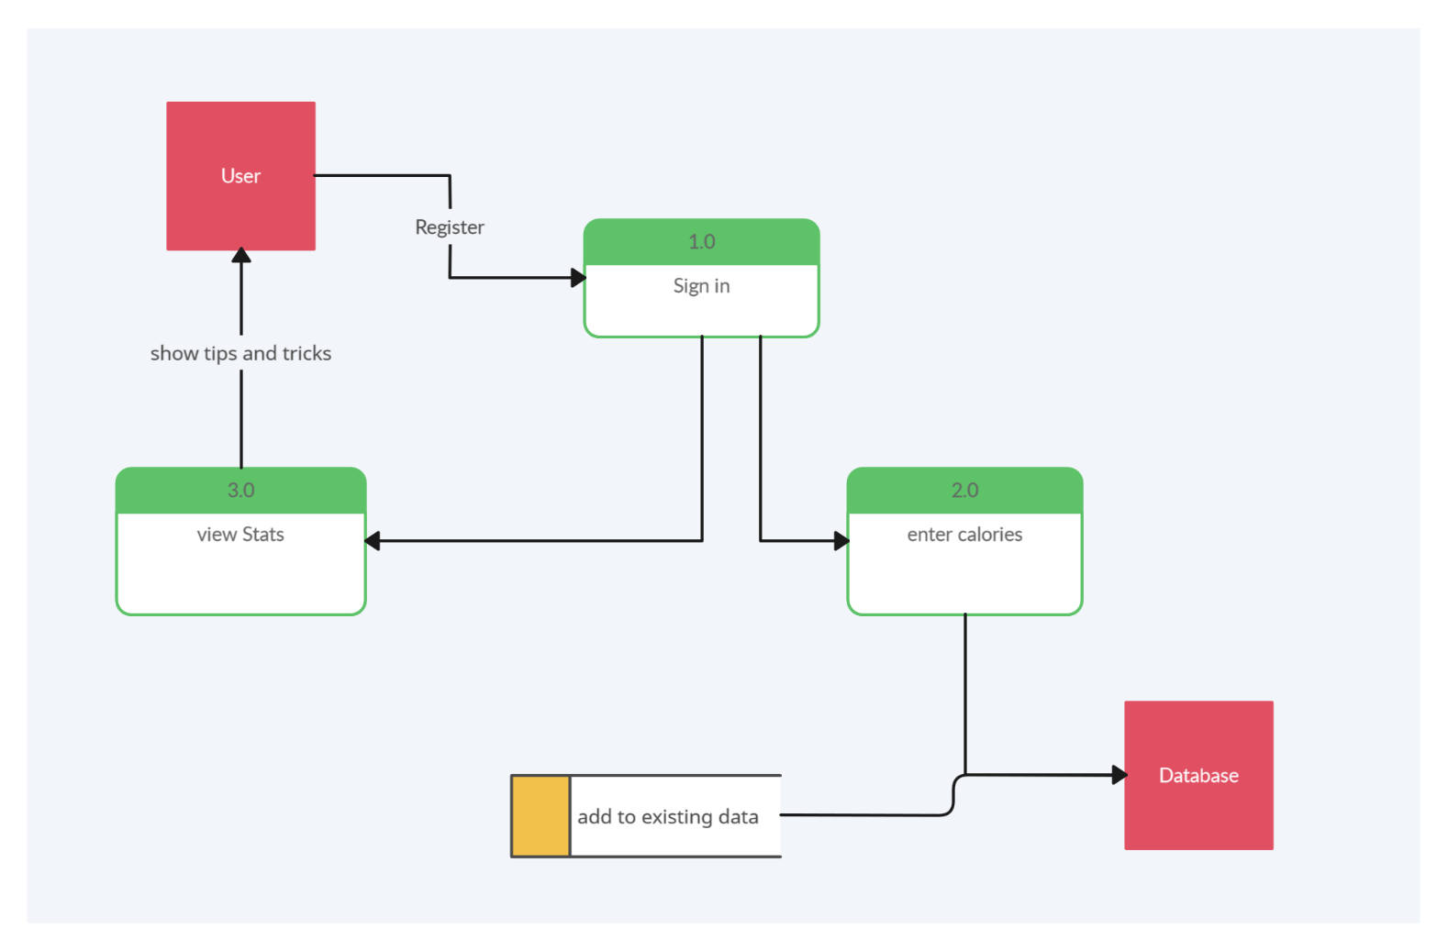
5. 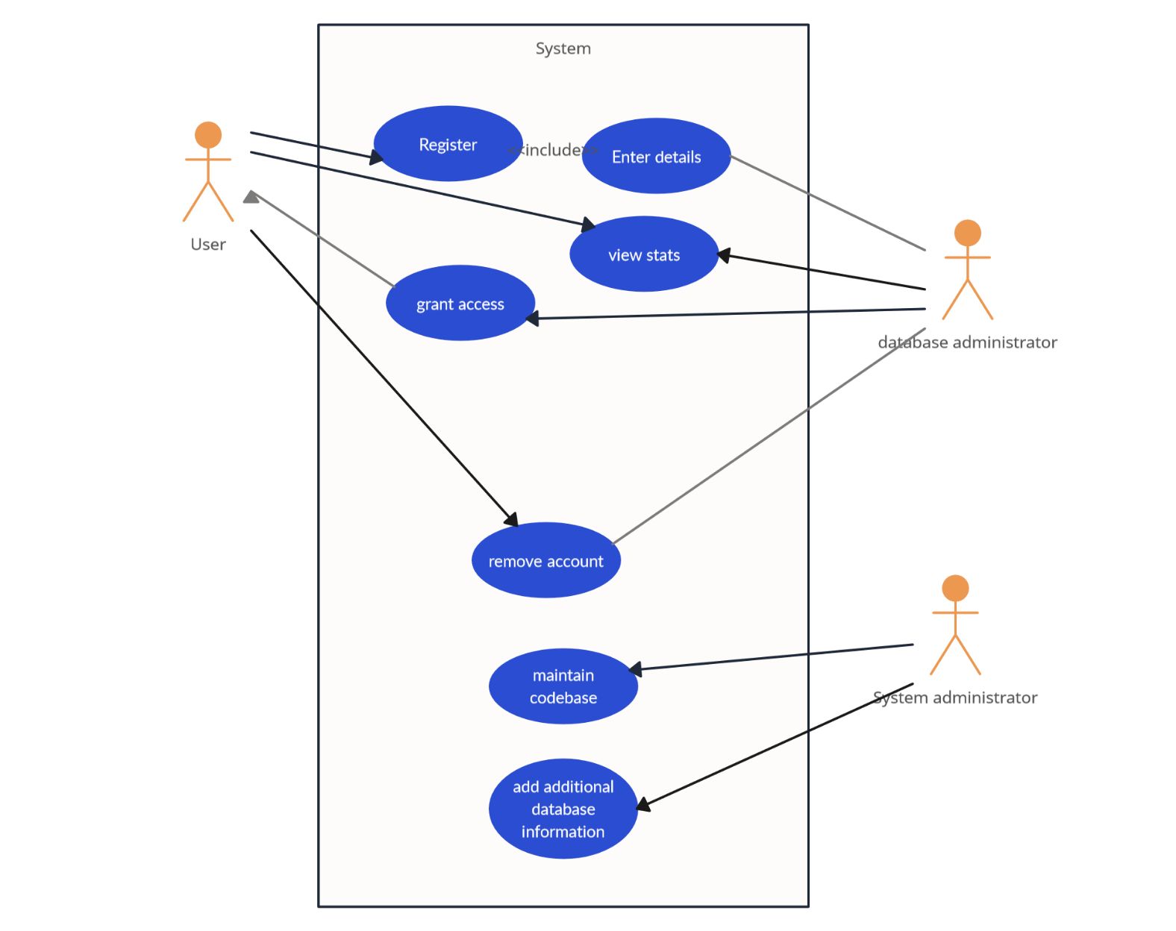
6. **Database Design**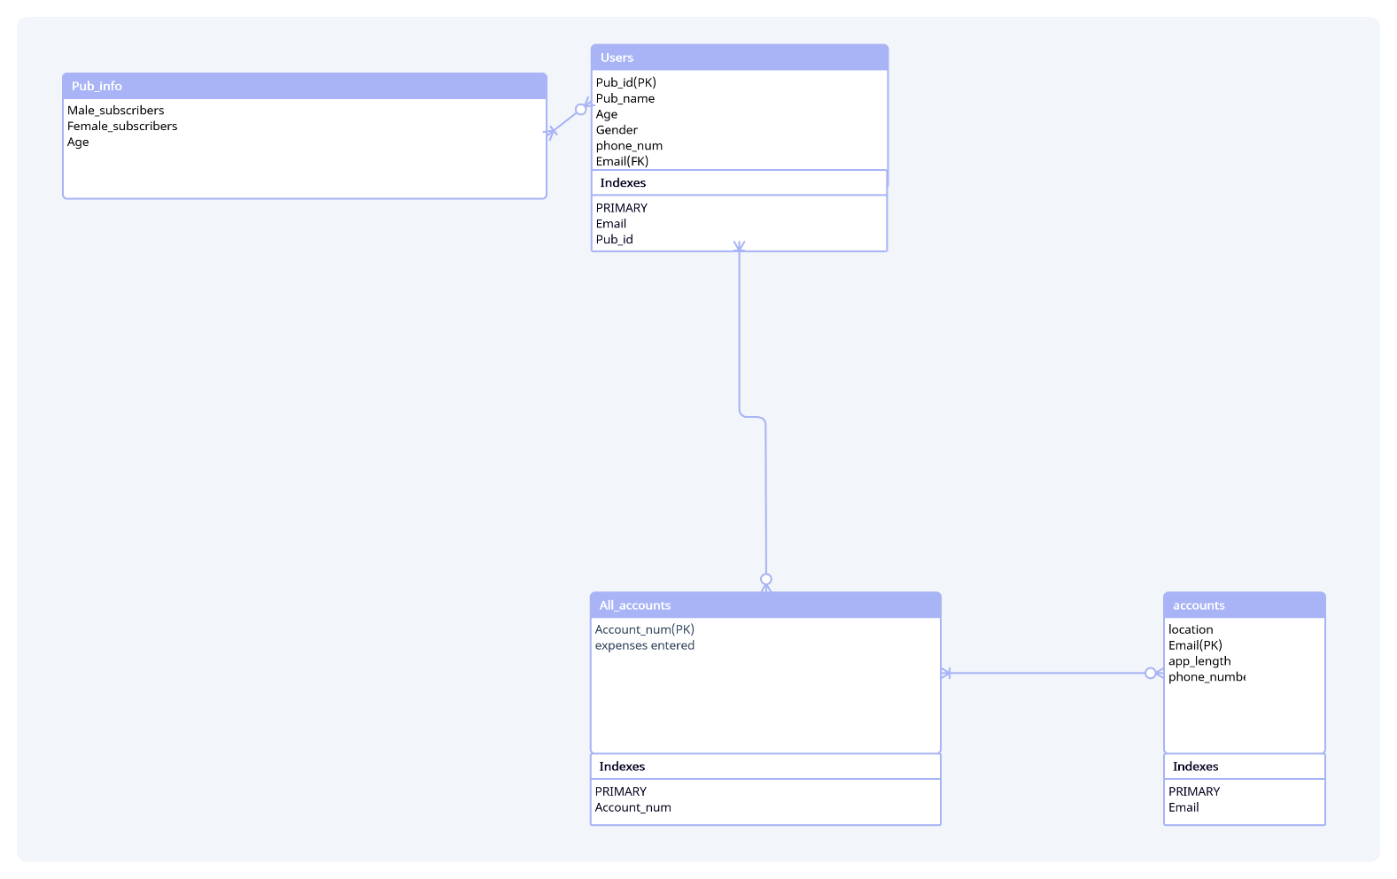

# Coding

Provide the screenshots and code samples of the final website. You do not have to print every code on your website. Use the following as guideline and explain what each sample code provided is used for on the website:

1. **Screenshots**
2. **Sample PHP Code**
3. **Sample HTML Code**
4. **Sample JavaScript Code**
5. **Sample CSS Code**
6. **Sample MySQL Table Screenshots**

# Conclusion

# Sign-off

|  |  |  |  |
| --- | --- | --- | --- |
|  |  |  |  |
| [Name], Project Client  Date: _____________________ |  |  | [Name], Project Manager  Date: _____________________ |